**Assignment : App Development**

For Learner Use:

|  |  |
| --- | --- |
| Surname of Learner | MAXAM |
| Name of Learner | MYOLISI |
| Learner ID | 9802045065083 |
| Student Number | ISCTICT18: MMAXAM |
| Date of Test Given | 12/08/2019 |
| Location / Branch | iStudent Academy, Cape Town |

For Assessors Use:

|  |  |
| --- | --- |
| Name of Branch | Cape Town |
| Name of Facilitator | Bradley Van Nelson |
| Name of Assessor | Bradley Van Nelson |
| Assessor Number | RAS/01/2017/0024 |
| Mark Allocation | 58 |
| Mark Obtained |  |
| Competency Status (C / NYC) |  |

|  |  |
| --- | --- |
| Unit Standards MICT Seta | 115392, 115388, 115384, 115431, 115363 |
| Units C&G | 039 |

|  |  |  |  |
| --- | --- | --- | --- |
| Candidates Signature | C:\Users\Sensei Maxam\Documents\Max.png | Date of Submission |  |
| Assessors Signature |  | Date Marked |  |

**Assignment set up:**

This assignment is made up of two tasks:

* **Task A -** Design and create software from a given design specification
* **Task B -** Test and document the software

**Grading criteria**

**Pass –** All criteria shown as [ ] and 34 criteria shown as ( ).

**Merit –** All criteria shown as [ ] and 39 criteria shown as ( ).

**Distinction -** All criteria shown as [ ] and 45 criteria shown as ( ).

**Scenario**

You work as a programmer for Omega Solutions who develop software for clients. You have been asked to design, create and test the software to access an external database. The interface to the database must enable the user to do the following:

* display individual records
* add a new record
* delete a record
* edit a record
* update a record
* cancel amendments for a record
* search records.

A database already exists named Hire containing a table tblCar which contains car details. The table tblCar contains the following fields:

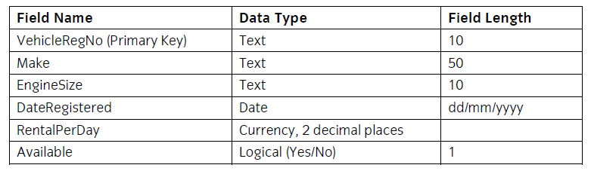

The VehicleRegNo field is a primary key and there cannot be duplicate entries in this field, and a zero-length entry is not allowed.

**Task A –** Design a five page website

In this task you are required to design and create software to access an external database (Hire) with a single table via a database connection and a data form.

Copy the database file(s) that you have been given into the same directory as your project. Make a backup copy of the file(s) in another directory.

Using the Integrated Development Environment:

1. Save the project at regular intervals as you work through the task. Save the form files as frmCars and frmSearch and the Project as CarsDatabase.

2.

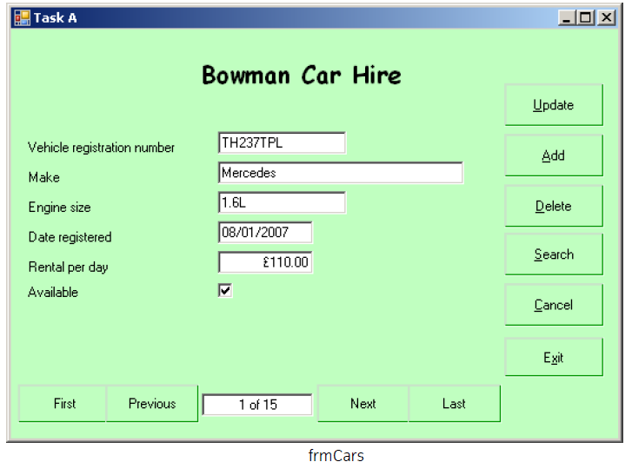

|  |
| --- |
| Create a data form that shows a single record to appear similar to the form shown above and includes:     * a label for the heading 'Bowman Car Hire' in bold with a different font and a larger font size * six controls and associated labels to display the data for the record * controls to move to the first, previous, next and last record * a control to hold a record count in the form n of nn * six buttons for Update, Add, Delete, Search, Cancel and Exit adding the shortcuts as shown * setting the background to a suitable colour * the data input controls receiving focus in an appropriate order. |

3 Set the Text property of the form frmCars to:Task A your name and today's date

4 Make a connection to the database Hire using suitable parameters.

5 Make sure that the formats of the displayed fields are as shown in frmCars.

6 Set up the program so that when the form frmCars is loaded the dataset is loaded automatically and the data for the first record is displayed in the controls.

7 Write code for the Update, Add, Delete and Cancel buttons.

8 Write code for the controls to move to the first, previous, next and last records.

9 Write code in a function to display the total record count and current record number each time one of the navigation buttons Is used. This will be displayed in the control associated with the navigation buttons as shown on the form frmCars.

10 Insert the code required to handle errors for database access which prevents run-time errors.

11 Write code for the Exit button to terminate the program.

12 Add a ToolTip control to the form frmCars.

13 Set the ToolTip property of THREE of the data entry controls on frmCars to an appropriate text value to assist the user when entering data eg for the Make data entry control 'Enter the make of the vehicle'.

14 Write code for the Search button to open a second form named frmSearch.

15 This following form is to be used to allow the user to specify a search criteria and display the matching records from the database table.

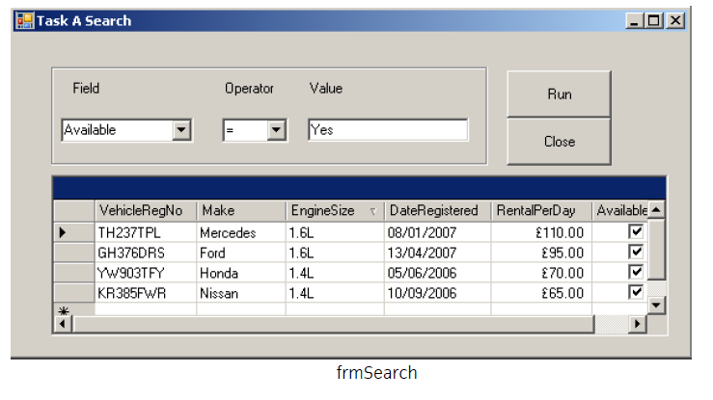

Create a new form frmSearch to appear similar to the form shown above and includes:

* a group box on the form to contain the following:

- two combo boxes named cboField and cboOperator with associated labels

- a text box for data entry with an associated label

* a DataGridView control to display the results of the search
* two buttons named btnRun and btnClose with the text Run and Close
* make sure that the formats of the displayed fields are as shown in frmSearch.

16 Save the form as frmSearch.

17 Set the Text property of form frmSearch to: Task A Search your name and today's date.

18 Write code in the Load function for the form to

* populate cboField with the field names Make, EngineSize, RentalPerDay and Available
* populate cboOperator with the following operator symbols, each one as a single list item: =, <, >, <=, >=

19 Write code for the Run button that will match the search criteria entered using the combo boxes and the value in the data entry text box. The fields VehicleRegNo, Make, EngineSize, DateRegistered, RentalPerDay and Available, for all the records which match the criteria, should be displayed in the data grid. The search should be run only if data exists in all three query criteria controls. A criteria string that is not matched by any record must return nothing.

20 Write code for the Close button to hide the form and return to the form frmCars.

***\**** ***Candidates should produce the following for their Assessor, as attachments to this assignment.***

* ***A printed program listing.***
* ***Screen prints of the forms frmCars and frmSearch.***
* ***The Code will also be assessed***

**Task B** - In this task you are required to test and document the software created.

1 Create test data and expected results to test the Update, Add, Delete, Cancel and Search buttons on the frmCars form and the Run button on the frmSearch form.

2 Prepare a test plan and test the software. Compare the actual results to the expected results keeping a log for each test which identifies any discrepancies between actual and expected results and records any amendments to correct errors. Use debugging tools to help locate and remove errors.

3 Locate the EXE file and run the executable file to demonstrate the software.

4 Produce technical documentation to describe the connection details and the purpose of the software.

5 Print a program listing and screen prints of the forms frmCars and frmSearch.

6 You should check that the program produced meets the following requirement:

* The program must conform to the design specification.
* The program uses the most appropriate controls and events.
* Meaningful names are used for constants, variables, objects, forms and controls using a consistent naming convention.

***\**** ***Candidates should produce the following for their Assessor, as attachments to this assignment.***

* ***Test data, test plan, expected results, actual results and log of testing.***
* ***Technical documentation.***
* ***The Code will also be assessed***